**WIREFRAME:**

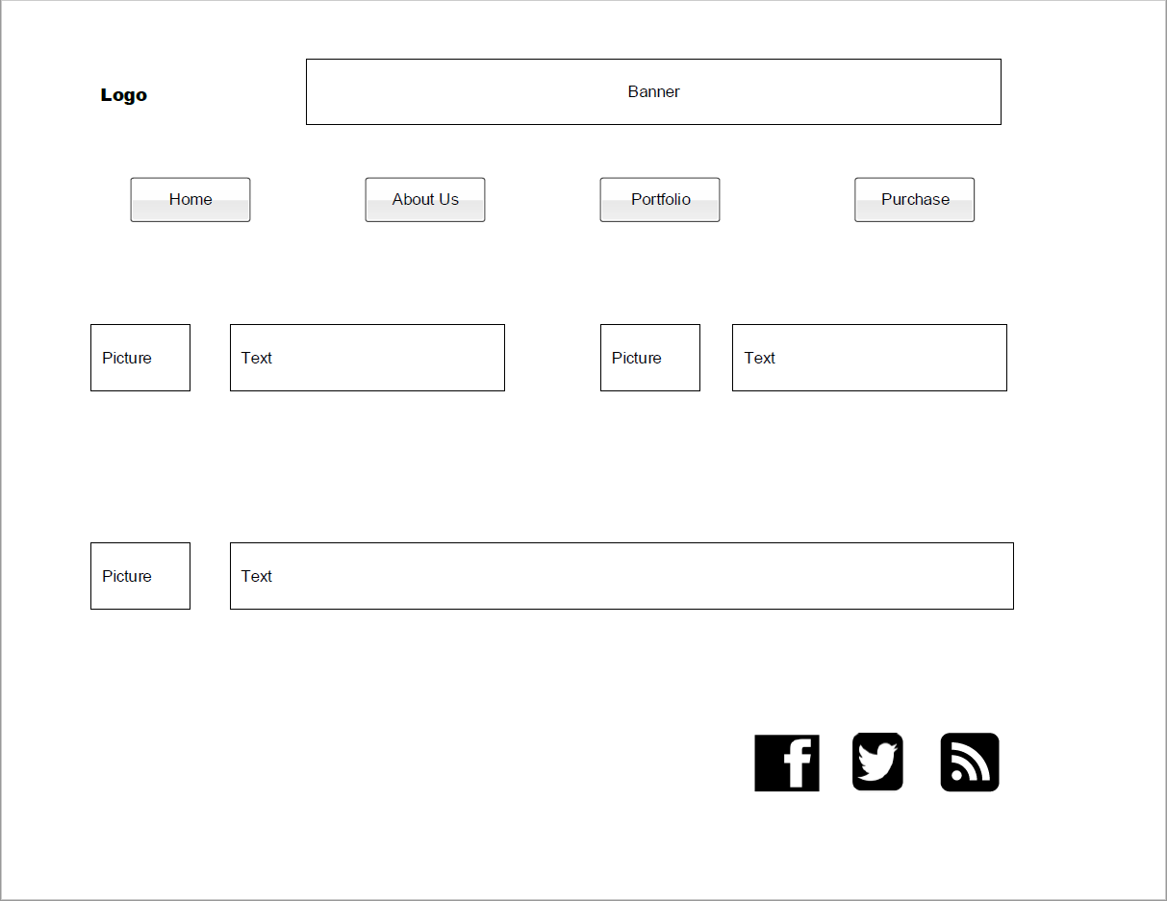

**URL OF MODULE 3 ACTIVITY:**

[**http://sotd.us/mariedebien/CIS4655C-MID/Module%203/Activity/MDebien_Mod%203%20Activity.html**](http://sotd.us/mariedebien/CIS4655C-MID/Module%203/Activity/MDebien_Mod%203%20Activity.html)

**GALAXY S5 SCREEN SHOTS:**

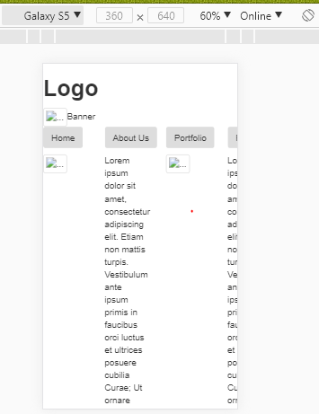

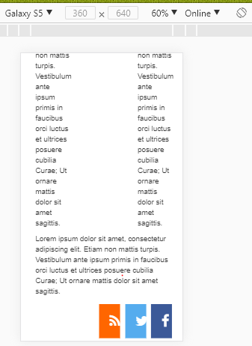

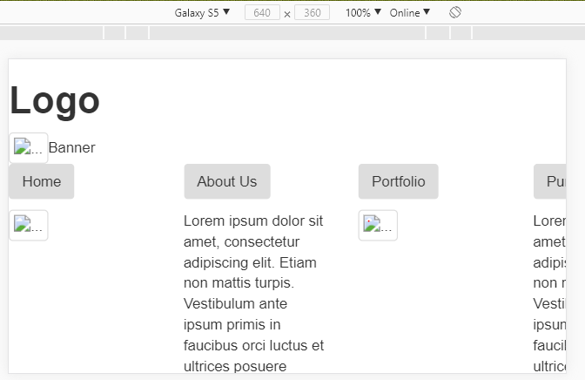

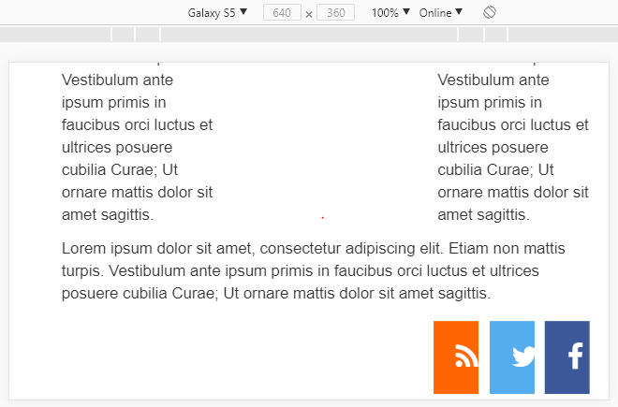

**iPhone 7 (Don’t have iPhone 6 option in Google Chrome Developer Tool):**

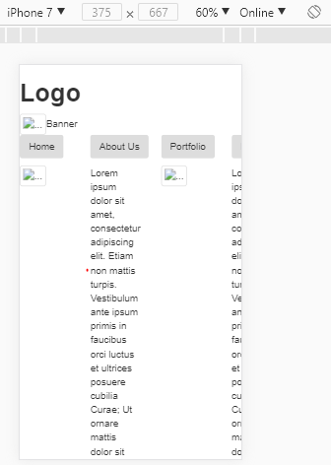

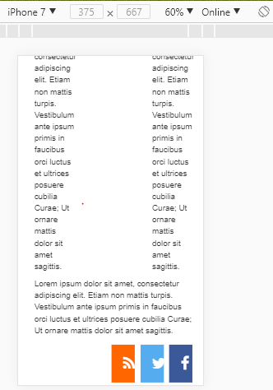

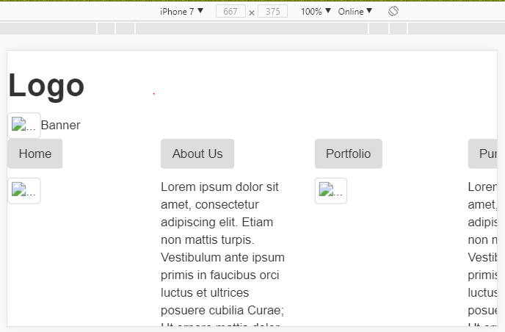

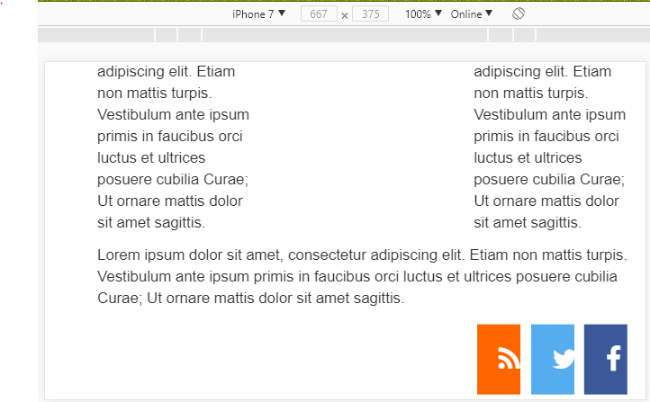

**iPad Pro:**

